2015 Madison West Women's Cross Country

15 November 2015

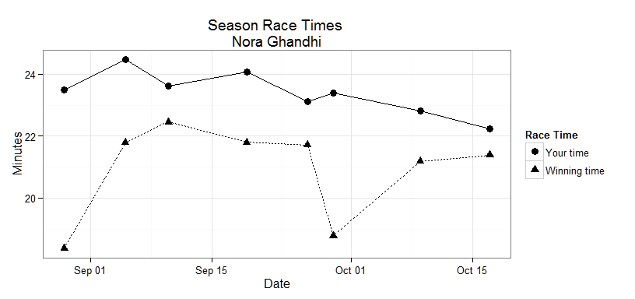

|  |  |  |  |  |  |
| --- | --- | --- | --- | --- | --- |
| Race | Date | Place | Winning Time | Time | Pace |
| West Bend_JR-SR | 2015-08-29 | 85 | 18:22 | 23:29.86 | 7:34 |
| Verona Invitational_JV | 2015-09-05 | 47 | 21:47 | 24:27.94 | 7:52 |
| West Invitational_JV | 2015-09-10 | 10 | 22:27 | 23:37 | 7:36 |
| Marquette Invitational_JV | 2015-09-19 | 33 | 21:48 | 24:04 | 7:45 |
| Janesville Invitational_JV | 2015-09-26 | 35 | 21:43 | 23:06.83 | 7:27 |
| Big 8 Jr | 2015-09-29 | 20 | 18:47 | 23:23 | 7:32 |
| MadCityChamionship_JV | 2015-10-09 | 16 | 21:11 | 22:49 | 7:21 |
| Janesville Big8_JV2 | 2015-10-17 | 15 | 21:23 | 22:14.50 | 7:10 |